1. **Service Benefits**:
   1. Makes the code leaner.
   2. Centralizes the code.
   3. Easier to maintain.
2. Working with event with service. Service provides communication b/w components.
3. 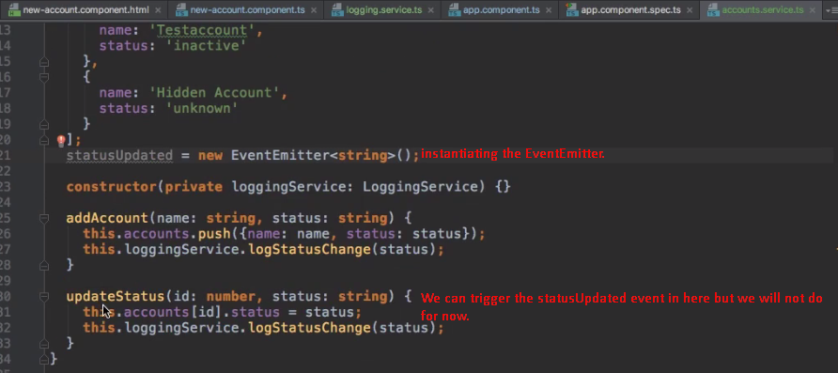
4. 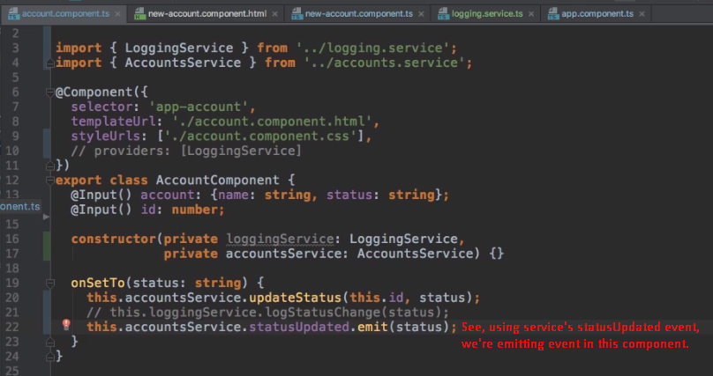  
   **NOTE**: Later, we will see Observable and Observer concept for event emission and subscription.
5. 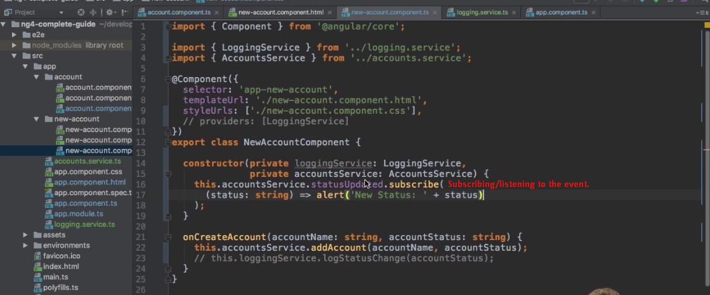  
   **NOTE**: See, we’re using event trigger and registration using service with emitter. Earlier, we did work with event trigger and registration using @Output property.
6. 